1. What is auto scaling ?

2. What is an elastic ip?

3. What is vpc peering ?

4. Docker commands?

5. Which pipelines you have used?

6. Ci/cd integration?

7. Jenkins configuration?

8. Terraform configuration files?

9. Team size ?

10. Do u face any conflicts when multiple people are working on a same file Tf, and how do u tackle it?

11. How do u create a simple ec2 instance using ansible?

12. How do u configure if u want to stop a particular task in a ansible playbook?

13. Configuration steps to create an ec2 instance in Tf?

14. How is the 3 tier architecture associated in your environment, could u tell me?

15. Ebs snapshot?

16. Folder & file structures in Tf?

17. Have you created any modules in the Tf? Or u r just changing the variables?

18. How will you pass the usernames and passwords to the tf configuration files?

19. What are the Tf extension files? TF and tf vars? Like u have branching startegies, where if you want to change the variables are you directly changing the files in variable.tf or do you have any extension files?

What is auto scaling ?

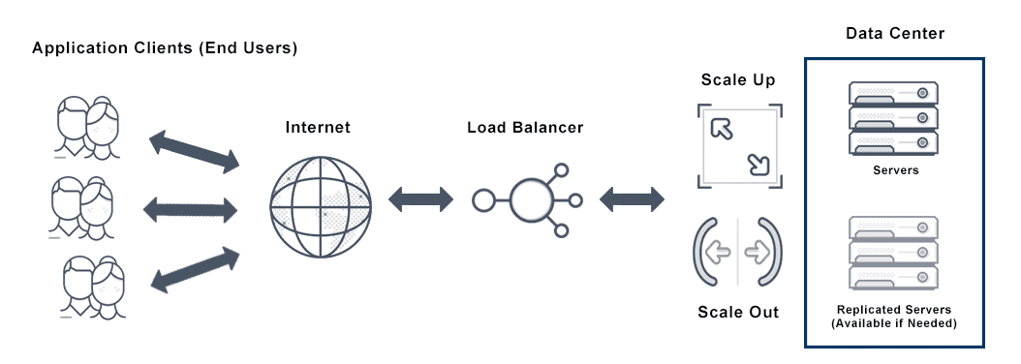

<https://avinetworks.com/glossary/auto-scaling/>

2. wt is diff eip vs public ip?

What is the difference between EIP and public IP?

A Public IP address associated with an instance is not static and is lost when the instance is stopped, whereas an Elastic IP address is a static public address associated with your AWS account.

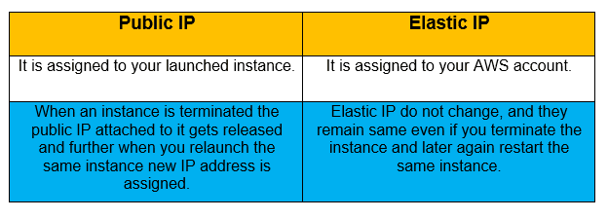

3. . What is vpc peering ?

A VPC peering connection is a networking connection between two VPCs that enables you to route traffic between them using private IPv4 addresses or IPv6 addresses. Instances in either VPC can communicate with each other as if they are within the same network.

<https://medium.com/awesome-cloud/aws-vpc-peering-overview-intro-getting-started-guide-6306304cab09>

4. Docker commands?

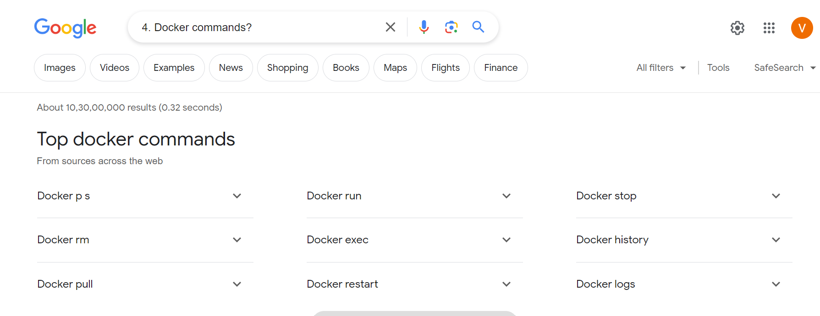

5.Which pipelines you have used?

Declarative

Scripted pipeline diff

<https://www.jenkins.io/doc/book/pipeline/>

6. explan the cicd with Jenkins intergration?

<https://k21academy.com/devops-foundation/ci-cd-pipeline-using-jenkins/>

7.wt are terraform configuration file?

<https://docs.aws.amazon.com/servicecatalog/latest/adminguide/getstarted-template-Terraform.html>

8. Team size ?

9. Do u face any conflicts when multiple people are working on a same file Tf, and how do u tackle it?

<https://serverfault.com/questions/983914/how-to-resolve-the-state-file-version-conflict-when-the-state-files-are-kept-in>

10. How do u create a simple ec2 instance using ansible?

<https://medium.com/@a_tsai5/creating-an-ec2-instance-using-ansible-764cf70015f6>

11. How do u configure if u want to stop a particular task in a ansible playbook?

How do I stop an Ansible playbook task?

To abort a playbook press ctrl+c and then a . Prompting for a set amount of time is not supported. Pausing playbook execution is interruptable but does not return user input. The pause module integrates into async/parallelized playbooks without any special considerations (see Rolling Updates).

12. 13. Configuration steps to create an ec2 instance in Tf?

https://www.middlewareinventory.com/blog/terraform-aws-example-ec2/

14. How is the 3 tier architecture associated in your environment, could u tell me?

<https://www.ibm.com/topics/three-tier-architecture>

15. 15. Ebs snapshot?

<https://docs.aws.amazon.com/AWSEC2/latest/UserGuide/EBSSnapshots.html>

16 Folder & file structures in Tf?

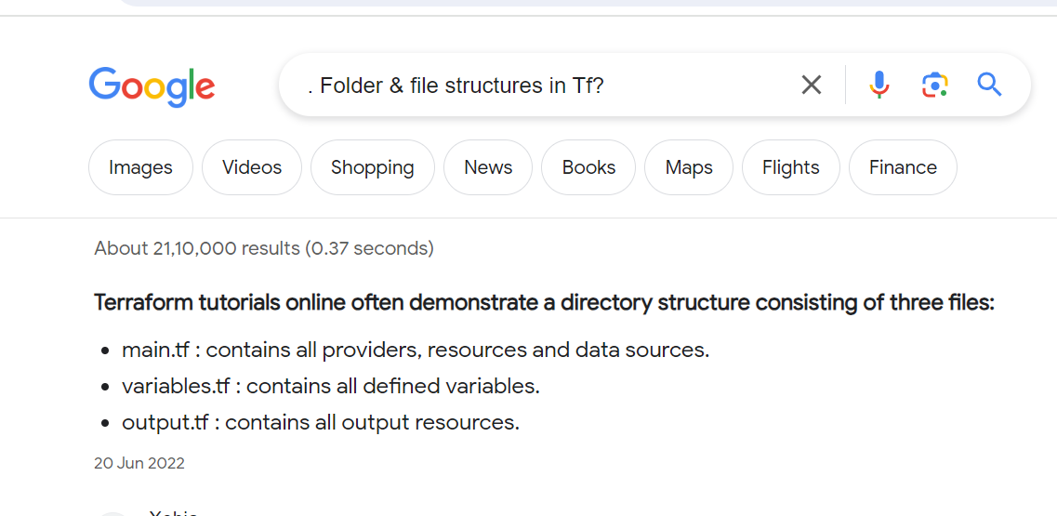

17. Have you created any modules in the Tf? Or u r just changing the variables?

<https://blog.gruntwork.io/how-to-create-reusable-infrastructure-with-terraform-modules-25526d65f73d>

18. How will you pass the usernames and passwords to the tf configuration files?

<https://stackoverflow.com/questions/68622936/how-can-i-pass-credentials-in-terraform>

19. 19. What are the Tf extension files? TF and tf vars? Like u have branching startegies, where if you want to change the variables are you directly changing the files in variable.tf or do you have any extension files?

<https://spacelift.io/blog/terraform-tfvars>